Assignment -4

Docker and Kubernetes

|  |  |
| --- | --- |
| Assignment Date | 23 November 2022 |
| Student Name | JAYALAKSHMI S |
| Student Roll Number | 813019104010 |
| Maximum Marks | 2 Marks |

1. **Pull an image from docker hub and run it in docker Playground**

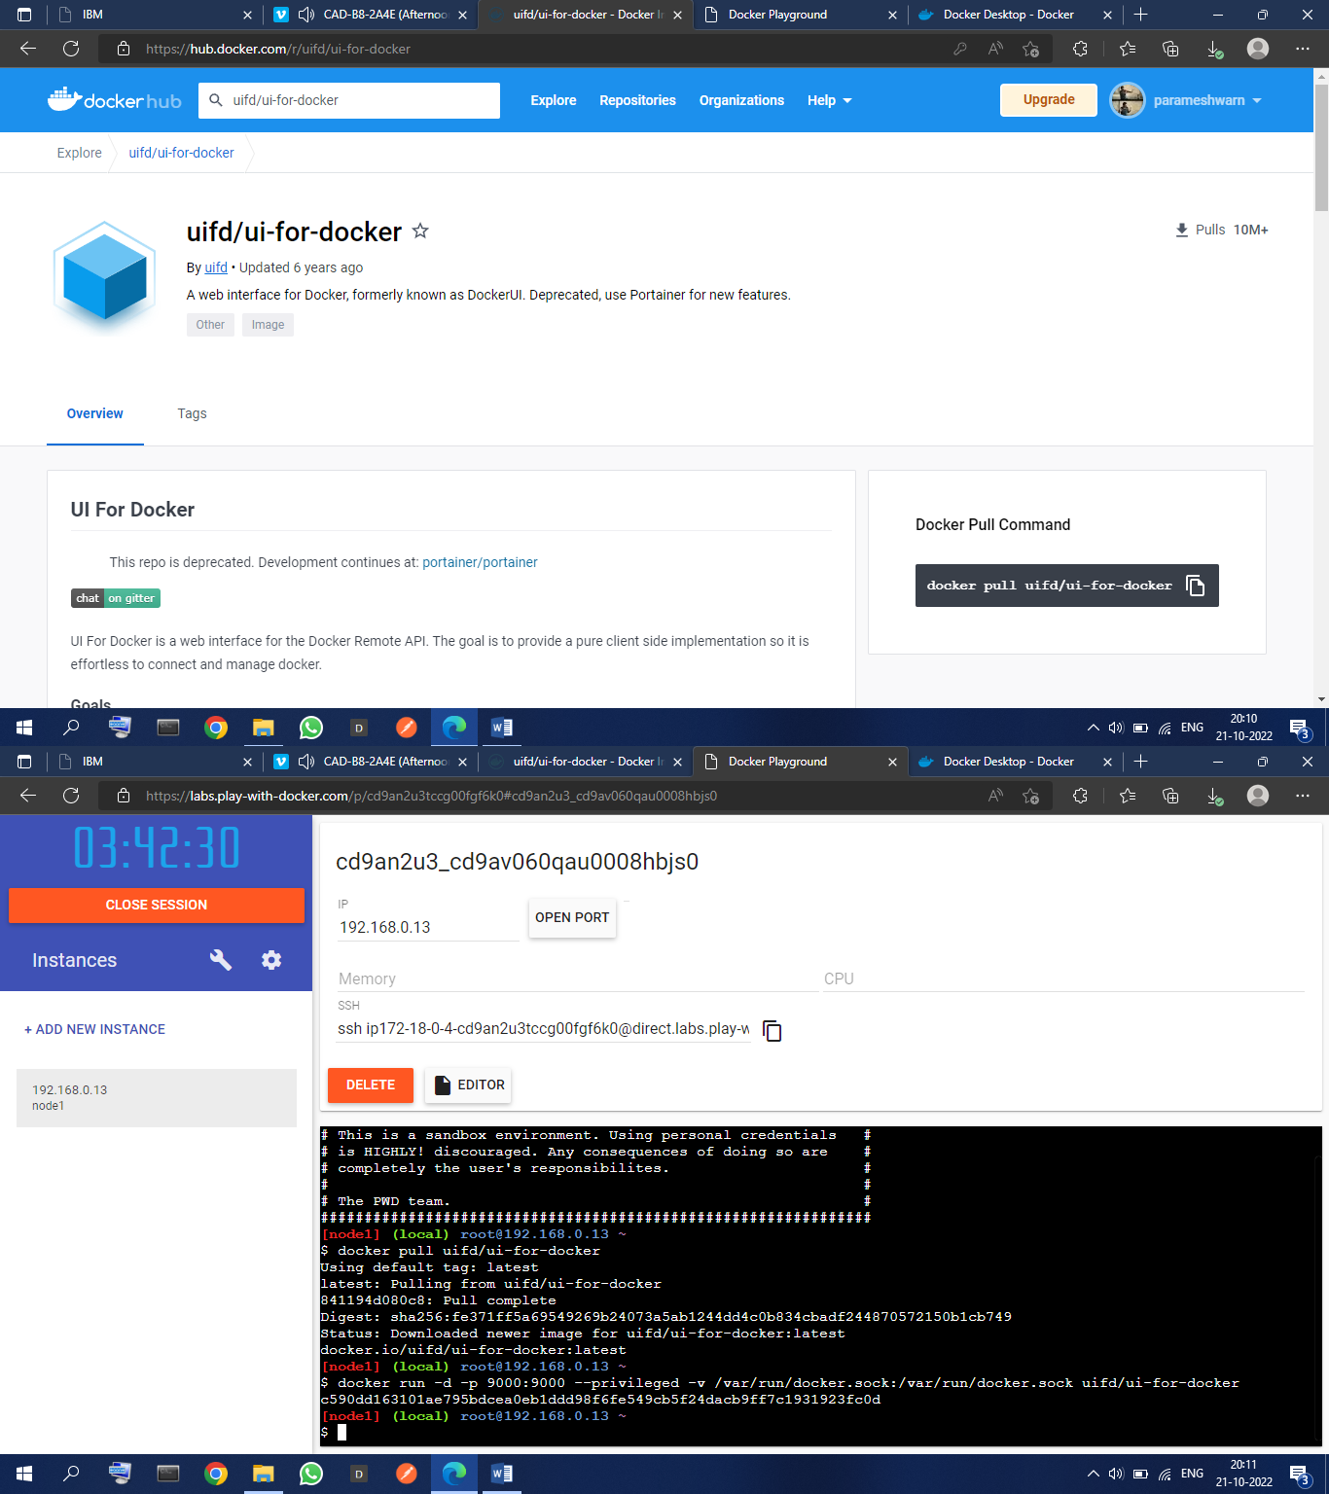

1. 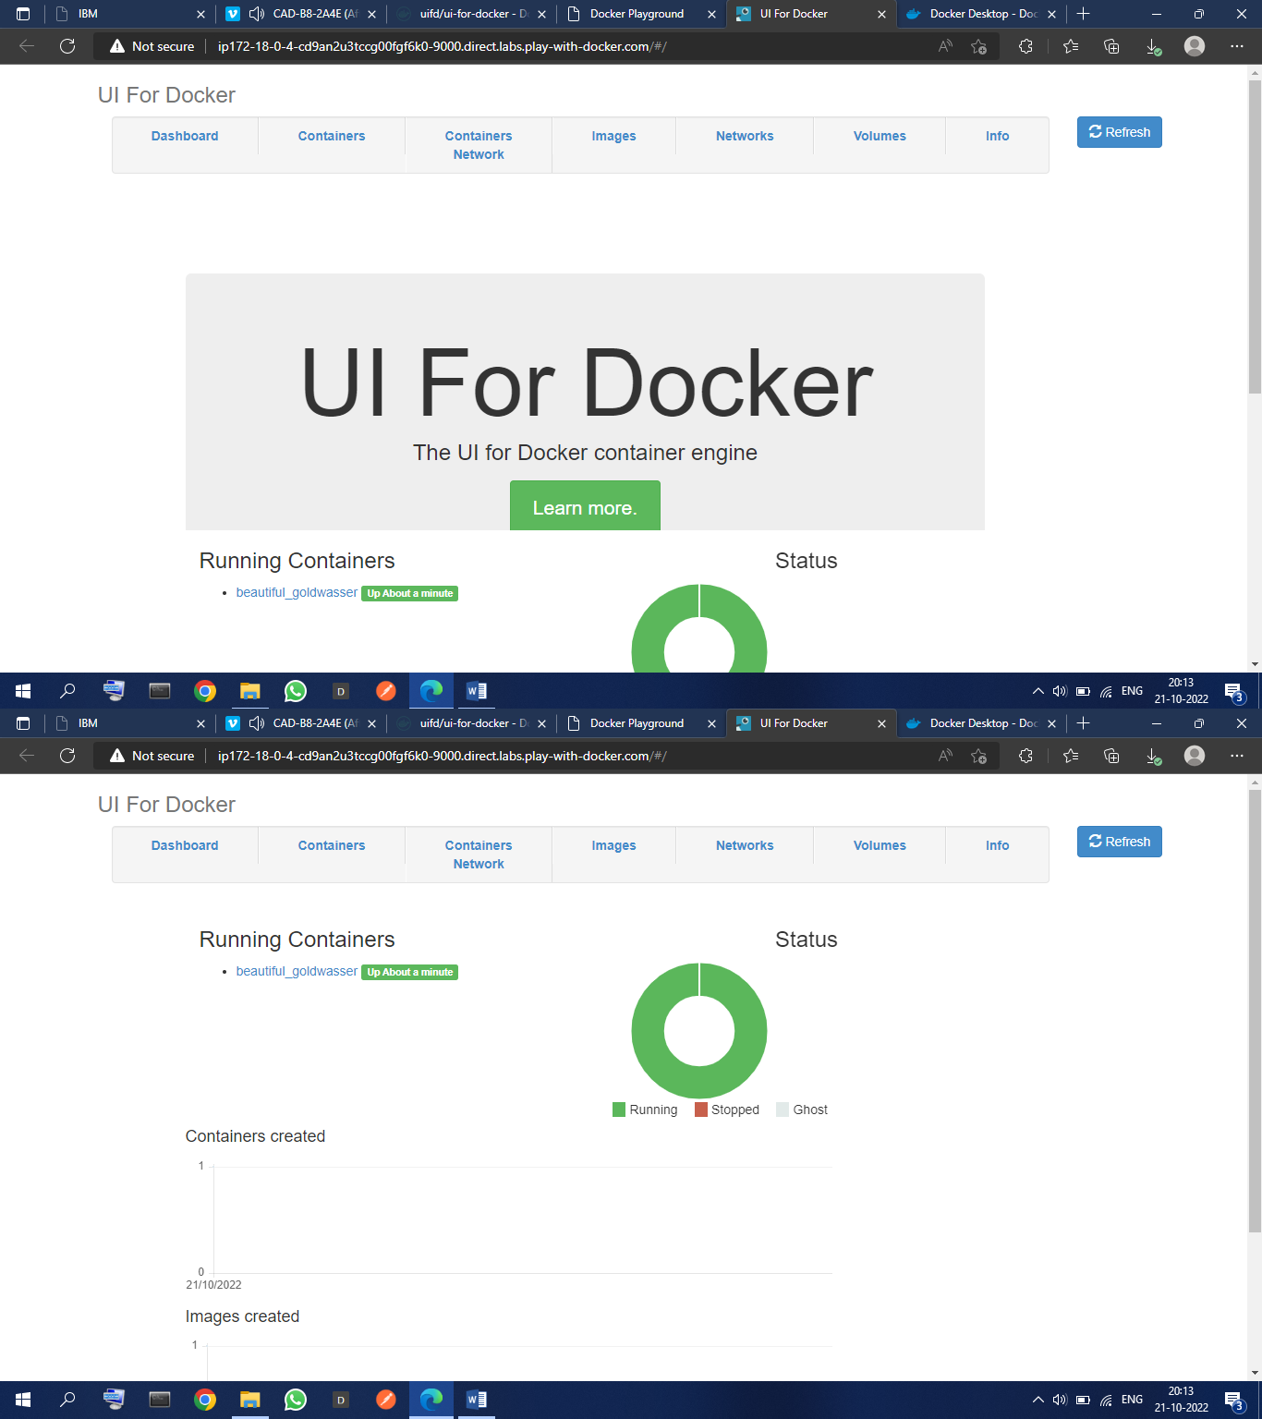**Create a docker file for the job portal application and deploy it in Docker desktop application**
2. 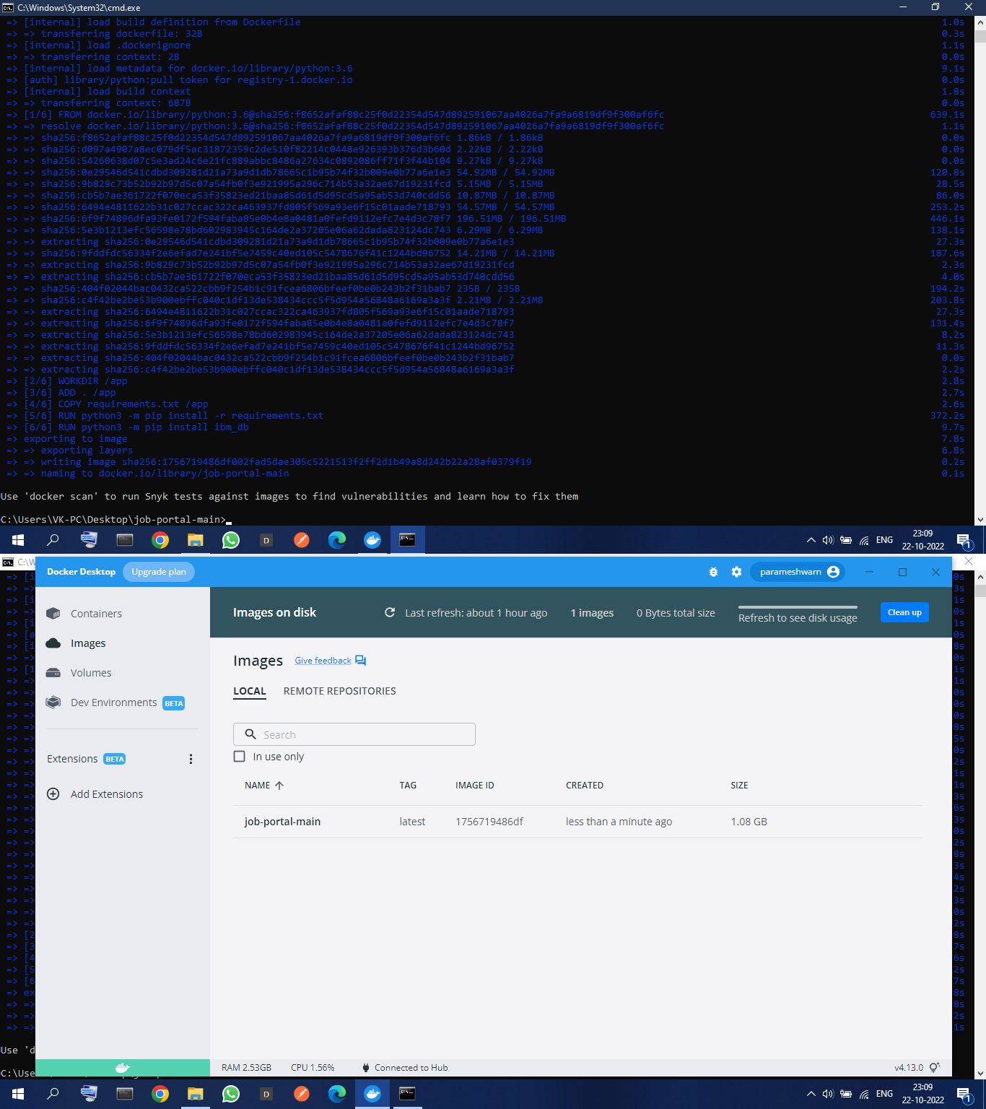**Create a IBM container registry and deploy helloword app**